Project Development Phase
Performance Test

Date | 20 february 2026
Team ID | LTVIP2026TMIDS72915
Project Name | Measuring the Pulse of Prosperity: An Index of Economic Freedom Analysis
Maximum Marks

Model Performance Testing:
Project team shall fill the following information in model performance testing template.
S.No. | Parameter | Screenshot / Values
 | Data Rendered | 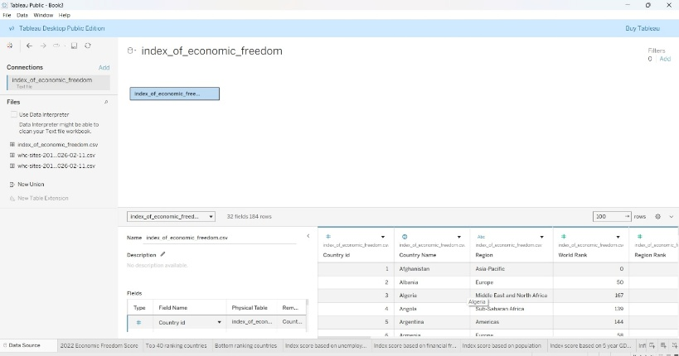
 | Data Preprocessing | 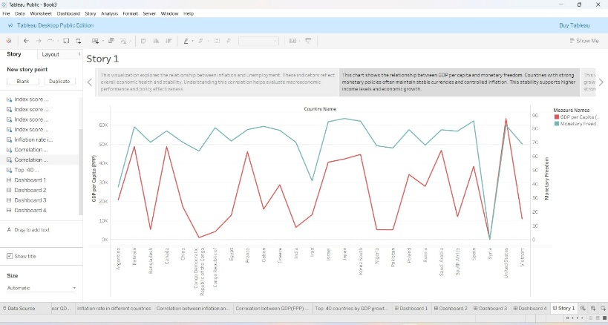
3. | Utilization of Filters | 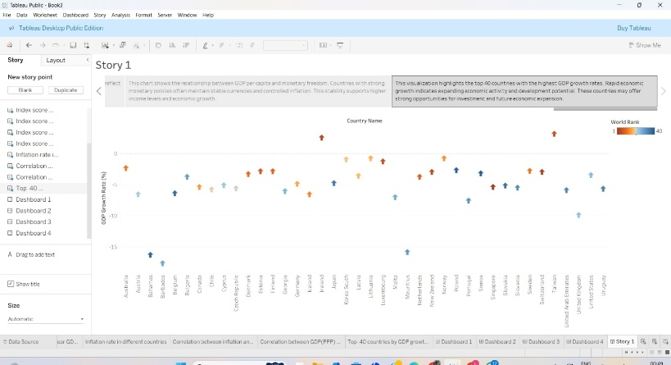
4. | Calculation fields Used | 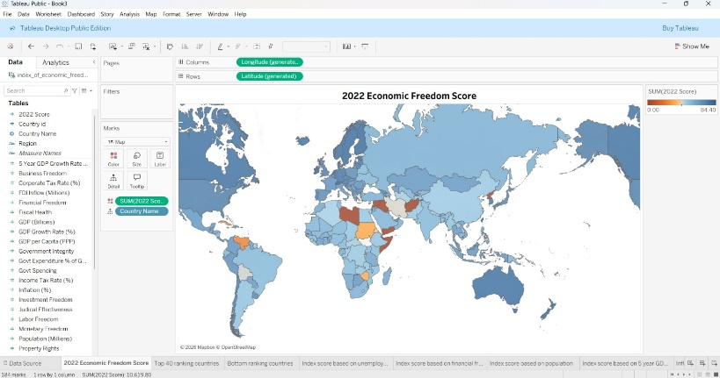
5. | Dashboard design | 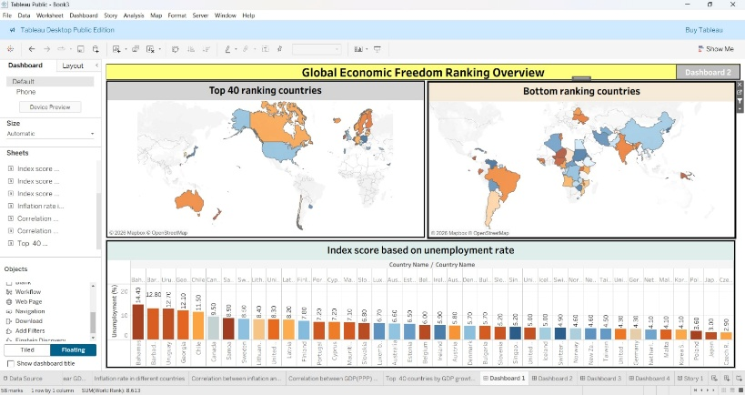  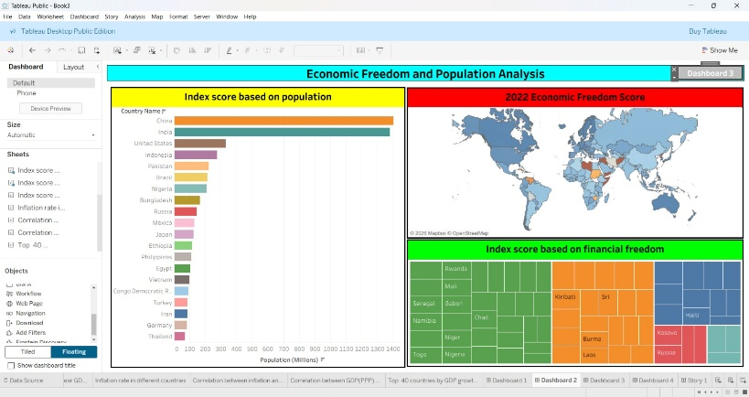  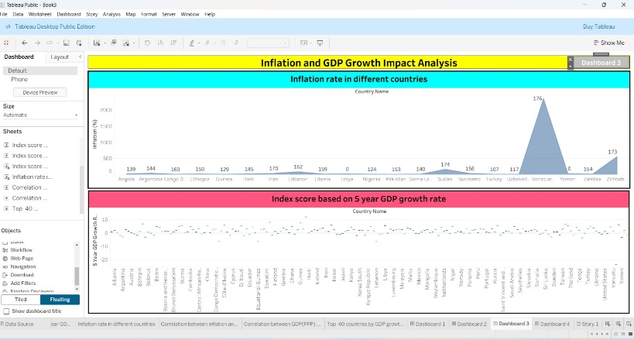  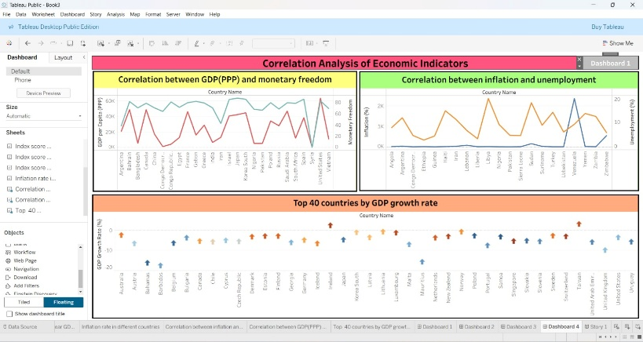
6 | Story Design | 